School: Duc Chinh Primary School  Class: 2  Name: | THE FIRST SEMESTER TEST  SUBJECT: ENGLISH - GRADE 2  SCHOOL YEAR: 2024 - 2025  Time: 35 mins

Marks | Listening |  | Reading and writing |  |  | Speaking | Comments
Marks | Q.1 | Q.2 | Q.3 | Q.4 | Q.5 | Q.6 | Comments
Part I: Listening: 5 points
1 |  |   √ | 2 | 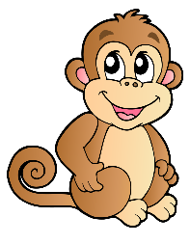 | 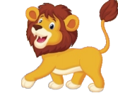
 | a. | b.
3 | 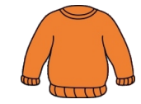 |  | 4 |  | 
 |  |  |  |  | b.
5 |  |  | 6 |  | 
Question 1: Listen and tick. There’s one example. (2.5 points)
Question 2: Listen and number. There’s one example. (2.5 points)
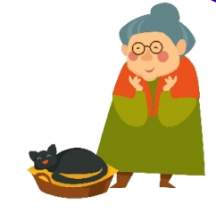 | 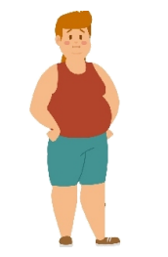  b.  1 |   c.
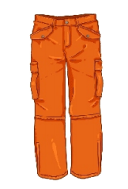  d. | 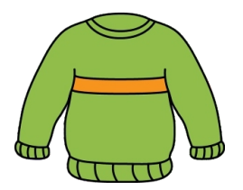  e. |   f.
Part II: Reading and writing: 4 points
Question 3: Look and read. Put a tick (√ ) or a cross (x) in the box.
There’re two examples. (2 points)
- It’s brown and yellow. |  | √
- My grandma is young. |  | X
- - “What colour is it?”  - “It’s black and white.” | 
- -“What is it?”  - “It’s an elephant.” | 
- They’re elephants.
- They’re my trousers.
Question 4: Look, read and circle. There’s one example. (1 point)
- It’s a dress. / hat. | 
- They’re sweaters. / shoes.
- This is my grandpa. / grandma.
- -“What is it?”  - “It’s a cow./ a giraffe.” | 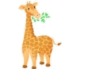
- They’re my skirts./ socks.
Question 5: Look at the pictures and the letters, write the words. There’s one example.
(1 point)
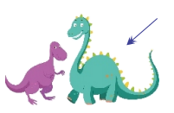  1. | 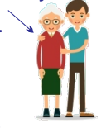  2. | 3. | 4. | 5.
g b i → b i g | l o d → _ _ _ | o i l → _ _ _ | a t h → _ _ _ | s s h o e → _ _ _ _ _

Part III: Speaking: 1 point
Question 6:
1. Listen and repeat.
2. Look and say.

