 | School: Duc Chinh Primary School  Class: 4  Name: |  |  |  |  |  |  |  | THE FIRST SEMESTER TEST  SUBJECT: ENGLISH - GRADE 4  SCHOOL YEAR: 2024 - 2025  Time: 35 mins
Mark |  | Listening |  |  |  | Reading and Writing |  |  |  |  |  | Speaking | Total
 |  | Q1 | Q2 | Q3 | Q4 | Q5 | Q6 | Q7 |  | Q8 | Q9
Comment:

PART I. LISTENING (15’)
Question 1:Listen and tick. There is one example.(1pt)
0. | 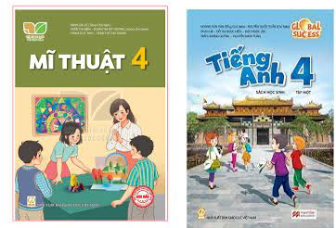  A. | 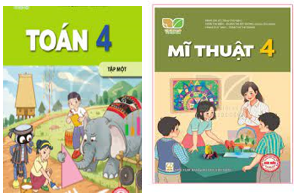  B. |   C.
1. |   A. |   B. |   C.
2. |   A. |   B. |   C.
3. |   A. |   B. |   C.
4. |   A. |   B. |   C.

Question 2: Listen and number. There is one example.(1pt)
A  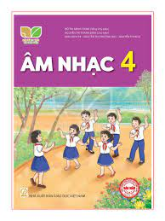 | B   | C   | D   | E  
0

Question 3: Listen and draw line. There is one example. (1pt)

 | A  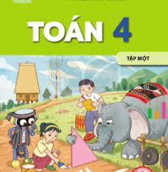 | B   | C   | D   | E  
4
3
2
1
0

Question 4: Listen and complete. There is one example.(1pt)
0. Nam can ride a bike.
1. I want to be a ………………………
2. She’s from …………………………
3. He goes to …………………at six fifteen.
4. What do you do on ………..………? – I listen to music.
PART II. READING AND WRITING (20’)
Question 5.Look at the pictures and the letters. Reorder the words. (1pt)
 |  |  |  | 
(0). niraBit  Britain | 1.nuringn  ____________ | 2. sepgar  __________ | 3. retapin  _________ | 4. saninomut  ___________
Question 6: Read and match the words with pictures. There is one example. (1pt)
0. buildings | A 
1. IT | B 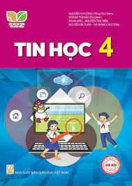
2. English teacher | C 
3. Australia | D 
4. listen to music | E 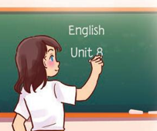
Question 7. Read and choose a, b or c to complete. There is one example. (1pt)
Hi ! My (0) name is Mary. I’m (1)______________America.
I’m (2)__________years old. My birthday is in (3)______________. I have many presents from my family. My parents give me a new blue bike and I receive a new pink doll from my sister. I’m very happy. What about you? (4)_____________your birthday?
0.a. English b.Vietnamese c.name
1. a. from b. singing c. cooking
2. a. America b. one c. nine
2. a. nineteen b. nine c. September
3. a. When b. When’s c. Where
Question 8. Read and tick (√) True or False. There is an example .(1pt)
Hello, My name is Lan. I have four friends: Mary, Lucy, Ben, Minh. Mary can play the piano, but she can’t play the guitar. Lucy can cook, but she can’t ride a bike. Ben can ride a horse, but he can’t draw. Minh can play football, but he can’t roller skate. I can cook, but I can’t swim. We all can sing and dance.
 |  | TRUE | FALSE
0. | Lan has three friends. |  | √
1 | Lan can swim but Lan can’t cook.
1. | Mary can play the piano, but she can’t play the guitar.
2. | Ben can ride a horse and draw.
3 | Lan, Mary, Lucy, Ben and Minh can sing and dance.
Question 9: Reorder the words. There’s one example (1pt)

(0). is/ What/ time/ it /?/

→ What time is it?

1. six/ I/ at/ breakfast/ have/ fifteen/./
……………………………………………………………………………..

2. school/ has/ My/ playground/ a/./
…………………………………………...………………………………..
…………………………………………………………………………………..

3. subject/your / What’s /favourite/ ? /
……………………………………………………………………………..

4. do/on/ I/ Sundays/ Saturdays/ and/ housework/./
…………………………………………...………………..………………..
…………………………………………………………………………………..

PART III: SPEAKING (1pt)
1. Get to know each other (Interview) | 2. Look, point and say
3. Let’s talk
-------------The End-------------
Giáo viên coi …………..…..…… Giáo viên chấm…………………………

ĐÁP ÁN, BIỂU ĐIỂM VÀ HƯỚNG DẪN CHẤM
BÀI KIỂM TRA CUỐI HỌC KÌ I – LỚP 4
Năm học: 2024 - 2025
Môn : TIẾNG ANH
Question | Answer |  |  |  | Point | Total
1 | 1. A | 2. B | 3. C | 4. B | 0,25/each | 1pt
2 | 1. D | 2.E | 3. A | 4. C | 0,25/each | 1pt
3 | 1. D | 2. A | 3. E | 4. C | 0,25/each | 1pt
4 | 1. painter | 2. Japan | 3. school | 4. Sundays | 0,25/each | 1pt
5 | 1. running | 2. grapes | 3. painter | 4. mountains | 0,25/each | 1pt
6 | 1. B | 2. E | 3. A | 4.D | 0,25/each | 1pt
7 | 1. A | 2.B | 3. C | 4. B | 0,25/each | 1pt
8 | 1. F | 2. T | 3. F | 4. T | 0,25/each | 1pt
9 | 1. I have breakfast at six fifteen.  2. My school has a playground.  3. What’s your favourite subject?  4. I do housework on Saturdays and Sundays. |  |  |  | 0,25/each | 1pt

TRANSCRIPTS OF THE TEST
Question 1. Listen and tick. There is one example.
- A:Where are you from, Nam?
B: I’m from Viet Nam.
- A: Hi, Ben. Can you roller skate?
B: No, I can’t. I can ride a bike
- A: What time is it?
B: It’s six o’clock. What time do you go to school?
A: I go to school at six fifteen.
4. A: Today is Sunday. What do you do on Sundays?
B: I listen to music.
Question 2.Listen and number. There is one example.
- A:When’s your birthday?
B: It’s in April.
- A: My school is in the village. Where’s your school?
B: It’s in the city.
- A: What subject do you have today?
B: I have Art, Music and PE
A: What’s your favourite subject?
B: It’s Music.
4. A: This is my new friend.
B: Where is he from?
A: He is from Britain.
Question 3. Listen and draw line.There is one example.
- A: What do you want to eat?
B: I want some chips.
- A: What subject do you have today?
B: I have Art, Maths and PE
A: What’s your favourite subject?
B: It’s Maths.
- A: Hello, I’m Tony.
B: Hi, Tony. Where are you from?
A: I’m from Britain.
4. A: What do you do at six thirty?
B: I read a book.
Question 4: Listen and complete. There is one example.
- A: What’s your favourite subject?
B: It’s art.
A: Why do you like art?
B: Because I want to be a painter.
- A: She is my new friend, Akiko
B: Where is she from?
A: She’s from Japan.
- A: What time is it?
B: It’s six o’clock.
A: What does he go to school?
B: He goes to school at six fifteen.
- A:What day is it today?
B: It’s Sunday.
A: What do you do on Sundays?
B: I listen to music.

MA TRẬN ĐỀ KIỂM TRA HỌC KỲ I - LỚP4
Môn: Tiếng Anh
Năm học: 2024 - 2025

Skills | Objectives to evaluate | Level/ point |  |  | Total
Listening |  | Level 1 | Level 2 | Level 3 | 16  4.0 pts  40%
 | Listen and tick | 1  0,25 | 2  0,5 | 1  0,25
 | Listen and number | 2  0,5 | 1  0,25 | 1  0,25
 | Listen and draw line. |  | 1  0,25 | 3  0,75
 | Listen and write | 3  0,75 |  | 1  0,25
Reading  and  Writing | Reorder the words | 2  0,5 | 2  0,5 |  | 12  3.0 pts  30%
 | Read and match |  | 2  0,5 | 2  0,5
 | Read and choose a, b, c to complete |  | 4  1
 | Read and tick True or False |  | 3  0,75 | 1  0,25 | 8  2.0 pts  20%
 | Reoder the words |  | 2  0,5 | 2  0,5
Speaking | Interview | 1  0,25 |  |  | 4  1.0 pt  10%
 | Look, point and say | 2  0,5
 | Let’s talk |  |  | 1  0,25
Total |  | 11  28% | 17  42% | 12  30% | 40  100%

