|  |  |  |  |  |  |  |  |  |  |  |  |  |  |
| --- | --- | --- | --- | --- | --- | --- | --- | --- | --- | --- | --- | --- | --- |
| **School: Duc Chinh Primary School**  **Class: 3**  **Name:** | | | | | | | | **THE SECOND SEMESTER TEST**  **SUBJECT: ENGLISH - GRADE 3**  **SCHOOL YEAR: 2023 - 2024**  **Time: 35 mins** | | | | | |
| **Mark** | | **Listening** | | | | **Reading and Writing** | | | | | | **Speaking** | **Total** |
|  | | Q1 | Q2 | Q3 | Q4 | Q5 | Q6 | Q7 | | Q8 | Q9 |  |  |
|  |  |  |  |  |  |  | |  |  |
| Comment: | | |  | | | | | | | | | | |

**PART I. LISTENING (15’)**

**Question 1: Listen and number. There is one example*.(1pt)***

|  |  |  |  |  |
| --- | --- | --- | --- | --- |
| **A** | **B** | **C** | **D** | **E** |
|  |  |  |  | **0**  **0** |

**Question 2: Listen and tick  the correct pictures. There is one example*.(1pt)***



0****

**2**

1. ****

**4**. ****

**3. **

***Question 3: Listen and circle. There is one example. .(1pt)***

**0.……………your book, please!**

1. *Open B. Close C. Speak*
2. Mai is……………………

A. flying a kite B. playing football C. playing volleyball

1. Minh is……………….

A. playing volleyball B. flying a kite C. flying a plane

1. How many ……………do you have ?

A. dogs B. goldfish C. parrots

4. Do you have any ………………?

A. dogs B. parrots C. goldfish

**Question 4: *Listen and write ONE WORD in each blank. There is one example.(1pt)***

1. ***A: What’s she doing?***

***B: She’s listening to music.***

1. A: What’s he doing?

B: He’s \_\_\_\_\_\_\_\_\_\_\_\_\_\_\_\_\_\_\_\_\_\_\_.

2.A: What’s he doing?

B: He’s \_\_\_\_\_\_\_\_\_\_\_\_\_\_\_\_\_\_\_\_\_\_\_a kite.

3.A: What’s she doing?

B: She’s \_\_\_\_\_\_\_\_\_\_\_\_\_\_\_\_\_\_\_\_\_\_\_.

4.A: What’s she doing?

B: She’s \_\_\_\_\_\_\_\_\_\_\_\_\_\_\_\_\_\_\_\_\_\_\_.

**PART II. READING AND WRITING (20’)**

***Question 5: Read and match .(1pt)***

1. What can you see ?

**b**.  It’s there.

1……..

0. Hi, Nam. How are you?

0 - e

**a**.  I’m writing.

2. What’s his job ?

2……..

**c**.  He’s a doctor.

3. Where’s the living room ?

3……..

**d**.  I can see a tiger.

4. What are you doing ?

4……..

**e**.  Fine, thank you.

***Question 6: Read and tick (v) or cross (x). There’s one example. .(1pt)***

|  |  |
| --- | --- |
| 1. I’m seven years old | 1. It’s a face   x |
| 1. It’s my sister. | 2. I’d like some rice, please |
| 3. She’s a worker. | 4. I can see a horse. |

***Question 7: Look, read and circle. There’s one example.(1pt).***

|  |  |
| --- | --- |
| 0. Let’s go to the …………. | A. library B. gym |
| 1. Would you like some……….? No, thanks | A. meat B. juice |
| 2. I have …………. dog. | A. two B. one |
| 3. They have …………… | A. trucks B. ships |
| 4. I’m ………………… | A. singing B. reading |

***Question 8. Read the passage and complete the sentences.There is one example.(1pt)***

Hello. My name's Nam.This is a photo of my family. My father is a cook. My mother is a teacher. She works in a Primary School. My sister is a worker and I’m a pupil. We are a happy family.

|  |  |
| --- | --- |
| 0. My name's **Nam**. |  |
| 1. Nam’s father is a \_\_\_\_\_\_\_\_\_\_\_\_\_\_\_\_\_\_ |
| 2. Nam’s mother is a \_\_\_\_\_\_\_\_\_\_\_\_\_\_\_\_\_ in a Primary School. |
| 3.Nam’s sister is a \_\_\_\_\_\_\_\_\_\_\_\_\_\_\_\_\_\_\_\_\_\_. |
| 4. They are a \_\_\_\_\_\_\_\_\_\_\_\_\_\_\_family. |

***Question 9: Order the words. There’s one example.***

1. ***you / are / How / ?*** 🡪 ***How are you ?***
2. would / you / eat / to / What / like / ?

🡪……………………………………………………………………………..

1. to / music / listening / I’m

🡪…………………………………………...………………………………..

🡪…………………………………………………………………………………..

1. farmer / a / she / Is / ?

🡪……………………………………………………………………………..

1. new / are / chairs / The

🡪…………………………………………...………………..………………..

🡪…………………………………………………………………………………..

**PART III: SPEAKING (1pt)**

|  |  |
| --- | --- |
| 1. Get to know each other (Interview) | 2. Look, point and say |
| 3. Let’s talk |  |

***-------------The End--------------***

Giáo viên coi …………..…..…… Giáo viên chấm…………………………

**ĐÁP ÁN, BIỂU ĐIỂM VÀ HƯỚNG DẪN CHẤM**

**BÀI KIỂM TRA CUỐI HỌC KÌ II – LỚP 3**

**Năm học: 2023 - 2024**

**Môn : TIẾNG ANH**

|  |  |  |  |  |  |  |
| --- | --- | --- | --- | --- | --- | --- |
| ***Question*** | *Answer* | | | | *Point* | *Total* |
| ***1*** | 1. C | 2. A | 3. D | 4. B | 0,25/each | 1pt |
| ***2*** | 1. B | 2.A | 3. A | 4. B | 0,25/each | 1pt |
| ***3*** | 1. A | 2. A | 3. B | 4. B | 0,25/each | 1pt |
| ***4*** | 1. singing | 2. flying | 3. drawing | 4. running | 0,25/each | 1pt |
| ***5*** | 1. D | 2. C | 3. B | 4. A | 0,25/each | 1pt |
| ***6*** | 1. X | 2. X | 3. V | 4.V | 0,25/each | 1pt |
| ***7*** | 1. A | 2. B | 3. A | 4. B | 0,25/each | 1pt |
| ***8*** | 1. cook | 2. teacher | 3. worker | 4. happy | 0,25/each | 1pt |
| ***9*** | 1. What would you like to eat?  2. I’m listening to music.  3. Is she a farmer ?  4. The chairs are new. | | | | 0,25/each | 1pt |

**PART III SPEAKING**

**Part 1: Interview(0.75pt)**

**Teacher gives students three questions related to personal information.**

1. What’s your name?

2. What is your brother’s job?

3. How many cats do you have?

**Part 2:Look, Point and say.(0.75pt)**

**Teacher shows two pictures for each question. Student listen and points then say aloud. (There are three questions)**

|  |  |
| --- | --- |
| **Flashcard 1** | **Flashcard 2** |
| U18_L1_3b | U18_L1_3c |
| Teacher: What is she doing?   * Student points to flashcard ……………………………………. | |
| U15_L2_2c | U15_L1_2a |
| Teacher: What would you like to drink?  Student points to flashcard ………………………………………….. | |
| U13_L2_2b | U14_L1_2d |
| Teacher: Where are the chairs?  Student points to flashcard ………………………………………….. | |

**Part 3: Let’s talk.(0.5pt)**

**Teacher show a picture and some cues. Student uses the cues to talk about the picture.**

* **Teacher says: Now you have 30 seconds to look at the picture and say aloud.**

I’m Mai. I have a kite. This is my friend. …

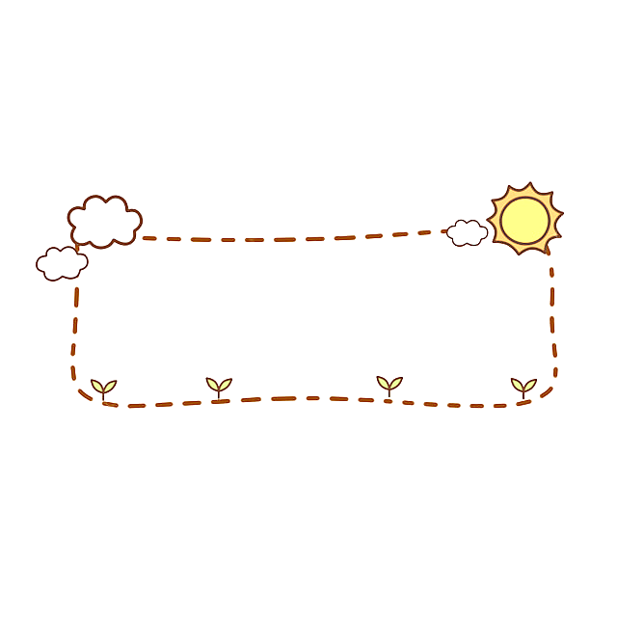

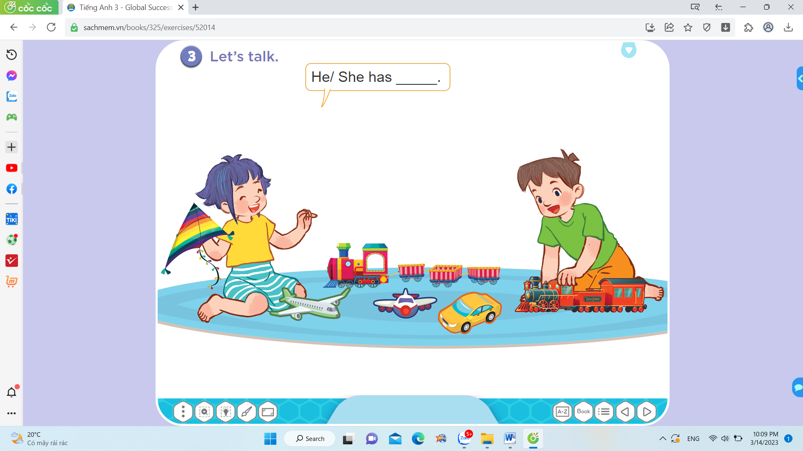

- Mai:

+ kite

+ plane

Her friend:

+ car

+ trains…..

**TRANSCRIPTION ( GRADE 3 )**

***Question 1: Listen and number***

1. A: What would you like to eat?

B: I’d like some beans.

2. A: Would you like some milk?

B: No, thanks.

3. A: Would you like some meat?

B: Yes, please.

4. A: What would you like to drink?

B: I’d like some water.

***Question 2: Listen and tick***

1. A: Is she a teacher?

B: Yes, she is.

2. A: Where’s the living room?

B: It’s here.

3. A: Where is the bed?

B: It’s in my bedroom.

4. A: What would you like to drink?

B: I’d like some orange juice.

***Question 3: Listen and circle***

1. Mai is flying a kite.

2. Minh is playing volleyball.

3. A: How many goldfish do you have?

4. A: Do you have any parrots?

***Question 4: Listen and write.***

1. What’s he doing? He’s **singing**.

2. What’s he doing? He’s **flying** a kite.

3. What’s she doing? She’s **drawing**.

4. What’s she doing? She’s **running**.

**MA TRẬN ĐỀ KIỂM TRA HỌC KỲ II - LỚP 3**

**Môn: Tiếng Anh**

**Năm học: 2023 - 2024**

|  |  |  |  |  |  |  |
| --- | --- | --- | --- | --- | --- | --- |
| **Kỹ năng** | **Nhiệm vụ đánh giá / kiến thức cần đánh giá** | **Mức / Điểm** | | | | **Tổng số câu, số điểm, tỷ lệ %** |
| Nghe | **M1** | **M2** | **M3** | **M4** | 16 câu  4.0 điểm  40% |
| ***Question 1: Listen and number***  1. A: What would you like to eat?  B: I’d like some beans.  2. A: Would you like some milk?  B: No, thanks.  3. A: Would you like some meat?  B: Yes, please.  4. A: What would you like to drink?  B: I’d like some water. | 1  0.25đ | 2  0.5đ | 1  0.25đ |  |
| ***Question 2: Listen and tick***  1. A: Is she a teacher?  B: Yes, she is.  2. A: Where’s the living room?  B: It’s here.  3. A: Where is the bed?  B: It’s in my bedroom.  4. A: What would you like to drink?  B: I’d like some orange juice. | 2  0.5đ | 2  0.5đ |  |  |
| ***Question 3: Listen and circle***  1. Mai is flying a kite.  2. Minh is playing volleyball.  3. A: How many goldfish do you have?  4. A: Do you have any parrots? | 2  0.5đ | 2  0,5đ |  |  |
| ***Question 4: Listen and write***  1. What’s he doing? He’s **singing**.  2. What’s he doing? He’s **flying** a kite.  3. What’s she doing? She’s **drawing**.  4. What’s she doing? She’s **running** |  | 1  0,25đ | 2  0,5đ | 1  0,25đ |
| Đọc  và  Viết | ***Question 5. Read and match*** |  | 2  0.5đ | 2  0.5đ |  | 8 câu  2.0 điểm  20% |
| ***Question 6. Look, read and tick*** |  | 1  0,25đ | 2  0,5đ | 1  0,25đ |
| ***Question 7. Look, read and circle*** | 1  0,25đ | 1  0,25đ | 1  0,25đ | 1  0,25đ | 12 câu  3.0 điểm  30% |
| ***Question 8. Read and complete the sentences.*** |  | 1  0,25đ | 1  0,25đ | 2  0,5đ |
| ***Question 9. Reorder the words to make sentences***  1. What would you like to eat?  2. I’m listening to music.  3. Is she a farmer ?  4. The chairs are new. | 1  0,25đ |  | 3  0,75đ |  |
| Nói | Get to know each other (Interview) | 1  0,25đ |  |  |  | 4 câu  1.0 điểm  10% |
| Point, ask and answer |  | 1  0,25đ |  |  |
| Listen and repeat |  |  | 1  0,25đ | 1  0.25đ |
| **Tổng** |  | 8  20% | 13  33% | 13  33% | 6  14% |  |