 | School: Duc Chinh Primary School  Class: 3  Name: |  |  |  |  |  |  |  | THE FIRST SEMESTER TEST  SUBJECT: ENGLISH - GRADE 3  SCHOOL YEAR: 2024 - 2025  Time: 35 mins
Mark |  | Listening |  |  |  | Reading and Writing |  |  |  |  |  | Speaking | Total
 |  | Q1 | Q2 | Q3 | Q4 | Q5 | Q6 | Q7 |  | Q8 | Q9
Comment:

PART I: LISTENING (15’)
Question 1. Listen and tick ( ) the box ( 1 point )

1 | a.  | b. 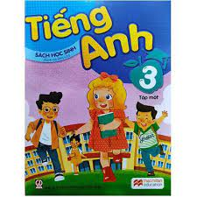 |   c.
2 | a.  | b.  | c. 
3 | a. 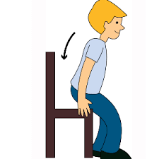 | b.  | c. 
4 |   a. | 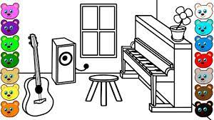b. |   c.

Question 2: Listen and number. (1 point)

a.  | b. 
c.  | d. 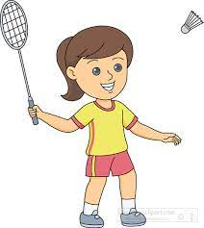

Question 3: Listen and match. (1 point)

a. | b. | c.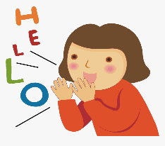 | d.
1 | 2 | 3
 |  |  | 4

Question 4: Listen and write. (1 point)
- Look! I have a ____________ pencil case.
- ______________ your notebook, please!
- How old are you, Mary?
I’m _____________ years old.
- What’s your hobby, Lucy? - I like __________________.
PART II: READING AND WRITING ( 20’).
Question 5: Read and circle (1 point).
1. Touch your ___________, please!  a. face b. hand c. hair | 
2. Do you have a ______________?  a. ruler b. book c. pencil | 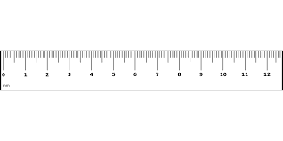
3. Is this our _____________?  a. art room b. gym c. music room | 
4. A: What do you do at break time?  B: I play ______________.  a. basketball b. football c. volleyball | 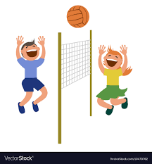

Question 6: Read and complete. (1 point).
They’re | eraser | green | school things

Look! I have many (1) _______________ in my school bag. I have an (2) _____________. It is red. I have a pencil case. It is (3) _____________ . I have two pens. (4) ____________ yellow. I have four pencils. They’re orange. I like my school things very much.
Question 7: Look and read. Put a tick ( ) or a cross () in the box. (1 point)
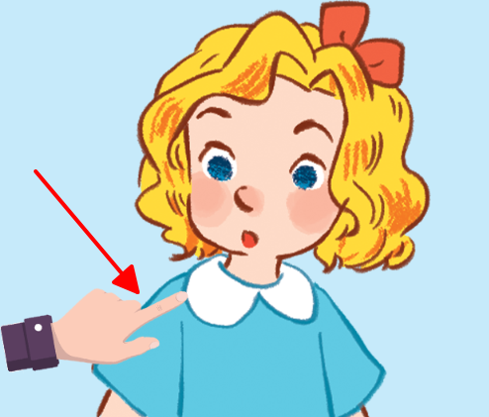  1. | 1. This is Mary.
  2. | 2. A: What’s your hobby?  B: It’s drawing.
  3. | 3. Open your mouth, please!
4.  | 4. A: Let’s go to the computer room.  B: Ok, let’s go.
Question 8: Look at the pictures and letters. Write the words. (1 point)
- hits |  | ……………………..
- nahd |  | ……………………..
- kbacl |  | ……………………..
- wradgin |  | ……………………..
Question 9: Reorder the words to make the sentences. (1 point)
1. a / you / Do / have / school bag? /
…………………………………………………………………………………….
2. art / Let’s / to / go / the / room. /
…………………………………………………………………………………….
3. Phong / running / likes / singing / and /. /
…………………………………………………………………………………….
4. time. / do / break / word / I / at / puzzles /
…………………………………………………………………………………….
PART III: SPEAKING ( 1 point )

1. Get to know each other (Interview) | 2. Point, ask and answer
3. Listen and repeat
-------------The End--------------
Giáo viên coi …………..…..…… Giáo viên chấm…………………………
ĐÁP ÁN, BIỂU ĐIỂM VÀ HƯỚNG DẪN CHẤM
BÀI KIỂM TRA CUỐI HỌC KÌ I – LỚP 3
Năm học: 2024 - 2025
Môn : TIẾNG ANH

Question | Answer |  |  |  | Point | Total
1 | 1. B | 2. C | 3. A | 4. B | 0,25/each | 1pt
2 | 1. D | 2. B | 3. A | 4. C | 0,25/each | 1pt
3 | 1. A | 2. C | 3. D | 4. B | 0,25/each | 1pt
4 | 1. blue | 2. Open | 3. five | 4. swimming | 0,25/each | 1pt
5 | 1. C | 2. A | 3. B | 4. C | 0,25/each | 1pt
6 | 1. school things | 2. eraser | 3. green | 4. They’re | 0,25/each | 1pt
7 | 1. V | 2. X | 3. V | 4. X | 0,25/each | 1pt
8 | 1. this | 2. hand | 3. black | 4. drawing | 0,25/each | 1pt
9 | 1. Do you have a school bag?  2. Let’s go to the art room.  3. Phong likes running and singing. /Phong likes singing and running.  4. I do word puzzles at break time. |  |  |  | 0,25/each | 1pt

TRANSCRIPTION 3
Question 1: Listen and tick the box
- A: Do you have a book?
B: Yes, I have.
- Touch your ears, please!
- A: May I sit down?
B: Yes, you can.
- A: I like listening to music.
OK. Let’s go to the music room.
Question 2: Listen and number
1. A: What do you do at break time, Linh?
B: I play badminton.
2. A: What’s your hobby, Phuong?
B: I like cooking.
3. A: Do you like dancing?
B: No, I don’t. I like swimming.
4. At break time, I play chess.
Question 3: Listen and match
1. Bye, Li Li.
2. A: May I speak English, Ms Hoa?
B: Yes, you can.
3. A: What’s your hobby, Minh?
B: It’s walking.
4. Touch your nose, please!
Question 4: Listen and write
- Look! I have a blue pencil case.
- Open your notebook, please!
- How old are you, Mary?
I’m five years old.
- What’s your hobby, Lucy?
I like swimming.

MA TRẬN ĐỀ KIỂM TRA HỌC KỲ I - LỚP 3
Môn: Tiếng Anh
Năm học 2024 - 2025
Kỹ năng | Nhiệm vụ đánh giá / kiến thức cần đánh giá | Mức / Điểm |  |  |  | Tổng số câu, số điểm, tỷ lệ %
Nghe |  | M1 | M2 | M3 | M4 | 16 câu  4.0 điểm  40%
 | Question 1: Listen and tick the box  - A: Do you have a book?  B: Yes, I have.  - Touch your ears, please!  - A: May I sit down?  B: Yes, you can.  - A: I like listening to music.  OK. Let’s go to the music room. | 1  0.25đ | 2  0.5đ | 1  0.25đ
 | Question 2: Listen and number  1. A: What do you do at break time, Linh?  B: I play badminton.  2. A: What’s your hobby, Phuong?  B: I like cooking.  3. A: Do you like dancing?  B: No, I don’t. I like swimming.  4. At break time, I play chess. | 2  0.5đ | 2  0.5đ
 | Question 3: Listen and match  1. Bye, Li Li.  2. A: May I speak English, Ms Hoa?  B: Yes, you can.  3. A: What’s your hobby, Minh?  B: It’s walking.  4. Touch your nose, please! | 2  0.5đ | 2  0,5đ
 | - Look! I have a blue pencil case.  - Open your notebook, please!  - How old are you, Mary?  I’m five years old.  - What’s your hobby, Lucy?  I like swimming. |  | 1  0,25đ | 2  0,5đ | 1  0,25đ
Đọc  và  Viết | Question 5. Read and circle  1. Touch your hair, please!  2. Do you have a ruler?  3. Is this our gym?  4. A: What do you do at break time?  B: I play volleyball. |  | 2  0.5đ | 2  0.5đ |  | 8 câu  2.0 điểm  20%
 | Question 6. Read and complete  1. school things 2. eraser  3. green 4. They’re |  | 1  0,25đ | 2  0,5đ | 1  0,25đ
 | Question 7. Look and read | 1  0,25đ | 1  0,25đ | 1  0,25đ | 1  0,25đ | 12 câu  3.0 điểm  30%
 | Question 8. Write the words  1. this 2. hand 3. black 4. drawing |  | 1  0,25đ | 1  0,25đ | 2  0,5đ
 | Question 9. Reorder the words to make the sentences  1. Do you have a school bag?  2. Let’s go to the art room.  3. Phong likes running and singing. /Phong likes singing and running.  4. I do word puzzles at break time. | 1  0,25đ |  | 3  0,75đ
Nói | Get to know each other (Interview) | 1  0,25đ |  |  |  | 4 câu  1.0 điểm  10%
 | Point, ask and answer |  | 1  0,25đ
 | Listen and repeat |  |  | 1  0,25đ | 1  0.25đ
Tổng |  | 8  20% | 13  33% | 13  33% | 6  14%

