 | School: Duc Chinh Primary School  Name:  Class: |  |  |  |  |  |  |  | THE SECOND SEMESTER TEST  SUBJECT: ENGLISH - GRADE 4  SCHOOL YEAR: 2022 - 2023  Time: 35 mins
Mark |  | Listening |  |  |  | Reading and Writing |  |  |  |  |  | Speaking | Total
 |  | Q1 | Q2 | Q3 | Q4 | Q5 | Q6 | Q7 |  | Q8 | Q9
Comment:

PART I. LISTENING (15’)

Question 1. Listen and tick () the picture ( 1pt ) 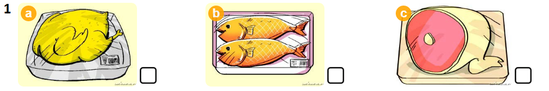
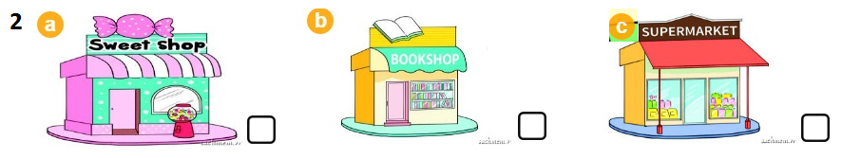
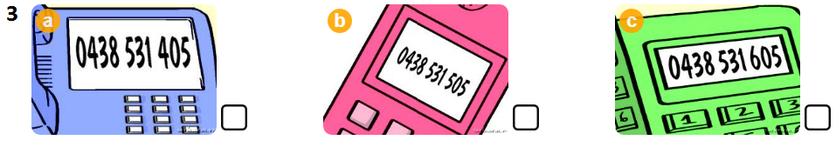
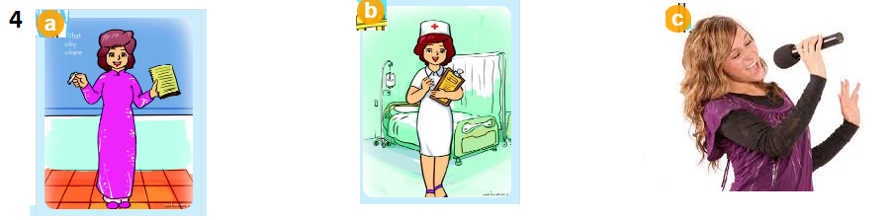
Question 2. Listen and number ( 1pt )
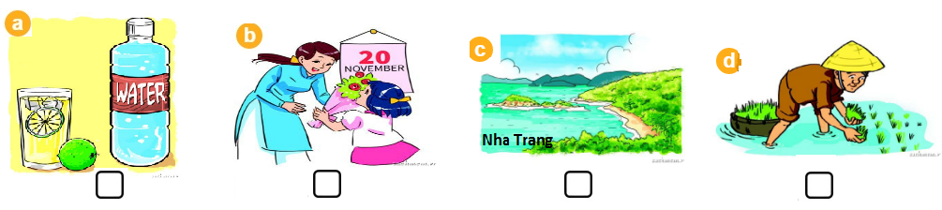

Question 3. Listen and write T (True) or F (False) ( 1pt )
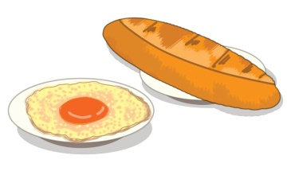
1. 2. 3. 4.

Question 4. Listen and write ONE word in each blank. ( 1pt )
1. How much is the _______________ ?
2. Would you like some ____________________ ?
3. I have ____________________ at 7 p. m .
4. My sister and I _________________ nice clothes at Tet.

PART II. READING AND WRITING (20’)
Question 5. Read and tick () the correct pictures ( 1pt )

1. The girls like playing volleyball.
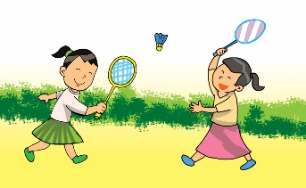  A. | B. | 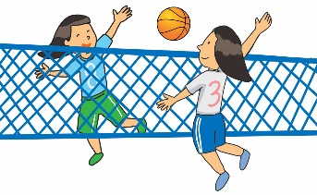  C.
2. The boys are playing football.
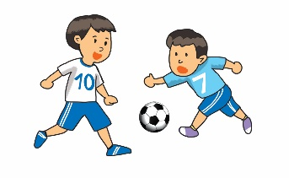  A. | B. | 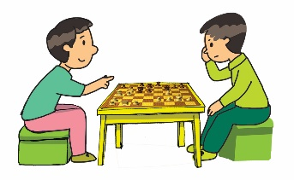  C.
3. My friends are going fishing.
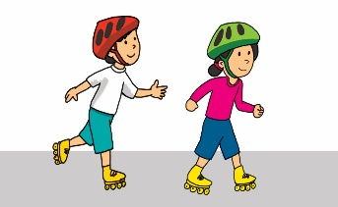  A. | 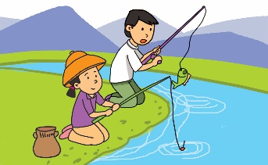  B. | C.
4. Jane is painting a picture.
A. | B. | C.
Question 6: Read and match ( 1pt )
A |  | B
1. Would you like some noodles? | 1…… | A. I like milk.
2. What time do you have lunch? | 2…… | B. They are 60,000 dong.
3. What’s your favourite drink? | 3…… | C. At 11 0’clock.
4. How much are the jeans? | 4……. | D. Yes, please.
Question 7. Look and write ( 1pt)
1. shaceTer → __ __ __ __ __ __ __ __’ Day

2. codretae → __ __ __ __ __ __ __ __ the house 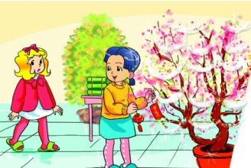

3. hdCrelni → __ __ __ __ __ __ __ __’s Day

4. rwefirko → __ __ __ __ __ __ __ __ displays

Question 8: Complete the dialogue . ( 1pt )
mother worker job Who
A: (1) ………………………… is this?
B: This is my (2)………………………… .
A: What’s her (3) ………………………?
B: She’s a nurse.
A: Is that your father?
B: Yes. He’s a (4) ………………………. .

Question 9: Reorder the words to make sentences ( 1pt )
1. is / Teachers’ Day? / When / _____________________________________________________
2. mother / is / in / My / doctor / a / hospital. / a / _____________________________________________________
3. you / go / a / Would / like / to / picnic? / for / ______________________________________________________
4. animal / see? / want / What / does / to / Nam / ______________________________________________________

PART III: SPEAKING (1pt)

1. Get to know each other (Interview) | 2. Point, ask and answer
3. Listen and repeat

-------------The End--------------

Giáo viên coi …………..…..…… Giáo viên chấm…………………………
ĐÁP ÁN, BIỂU ĐIỂM VÀ HƯỚNG DẪN CHẤM
BÀI KIỂM TRA CUỐI HỌC KÌ II – LỚP 4
Năm học: 2022 - 2023
Môn : TIẾNG ANH

Question | Answer |  |  |  | Point | Total
1 | 1. a | 2. c | 3. b | 4. a | 0,25/each | 1pt
2 | 1. b | 2. d | 3. c | 4. a | 0,25/each | 1pt
3 | 1. T | 2. F | 3. F | 4. T | 0,25/each | 1pt
4 | 1. jacket | 2. bread | 3. dinner | 4. wear | 0,25/each | 1pt
5 | 1. C | 2.A | 3. B | 4. C | 0,25/each | 1pt
6 | 1. D | 2. C | 3. A | 4. B | 0,25/each | 1pt
7 | 1. Teachers | 2. decorate | 3.Children | 4. firework | 0,25/each | 1pt
8 | 1. Who | 2. mother | 3. job | 4. worker | 0,25/each | 1pt
9 | 1. When is Teachers’ Day?  2. My mother is a doctor in a hospital.  3. Would you like to go for a picnic?  4. What animal does Nam want to see ? |  |  |  | 0,25/each | 1pt

TRANSCRIPTION ( GRADE 4 )

Question 1: Listen and tick the picture
1. My favourite food is chicken.
2. Let’s go to the supermarket. I want to buy some food.
3. A: What’s your phone number?
B: It’s 0438 531 505.
4. A: What does your mother do?
B: She’s a teacher.
Question 2: Listen and number.
1. We give our teachers lots of flowers on Teachers’ Day.
2. A: Where does a farmer work?
B: A farmer works in a field.
3. I’m going to Nha Trang this summer.
4. A: What’s your favourite drink?
B: It’s water.
Question 3: Listen and write T (True) or F (False)
1. A: Would you like some fish?
B: Yea, please.
2. Our favourite food is chicken.
3. I’d like some rice with eggs, please.
4. Lemonade is my favourite drink.
Question 4: Listen and write.
1. How much is the jacket?
2. Would you like some bread?
3. I have dinner at 7 p. m .
4. My sister and I wear nice clothes at Tet.

MA TRẬN ĐỀ KIỂM TRA HỌC KỲ II - LỚP 4
Môn: Tiếng Anh
Năm học: 2022 - 2023

Kỹ năng | Nhiệm vụ đánh giá / kiến thức cần đánh giá | Mức / Điểm |  |  |  | Tổng số câu, số điểm, tỷ lệ %
Nghe |  | M1 | M2 | M3 | M4 | 16 câu  4.0 điểm  40%
 | Question 1: Listen and tick.  1. My favourite food is chicken.  2. Let’s go to the supermarket. I want to buy some food.  3. A: What’s your phone number?  B: It’s 0438 531 505.  4. A: What does your mother do?  B: She’s a teacher. | 1  0.25đ | 2  0.5đ | 1  0.25đ
 | Question 2: Listen and number  1. We give our teachers lots of flowers on Teachers’ Day.  2. A: Where does a farmer work?  B: A farmer works in a field.  3. I’m going to Nha Trang this summer.  4. A: What’s your favourite drink?  B: It’s water. | 2  0.5đ | 2  0.5đ
 | Question 3: Listen and tick T or F  1. A: Would you like some fish?  B: Yea, please.  2. Our favourite food is chicken.  3. I’d like some rice with eggs, please.  4. Lemonade is my favourite drink. | 2  0.5đ | 2  0,5đ
 | Question 4: Listen and write ONE word in each blank  1. How much is the jacket?  2. Would you like some bread?  3. I have dinner at 7 p. m .  4. My sister and I wear nice clothes at Tet. |  | 1  0,25đ | 2  0,5đ | 1  0,25đ
Đọc  và  Viết | Question 5. Read and tick the correct pictures |  | 2  0.5đ | 2  0.5đ |  | 8 câu  2.0 điểm  20%
 | Question 6. Read and match |  | 1  0,25đ | 2  0,5đ | 1  0,25đ
 | Question 7. Look and write  1. Teachers’ Day  2. decorate  3. Children’s Day  4. firework | 1  0,25đ | 1  0,25đ | 1  0,25đ | 1  0,25đ | 12 câu  3.0 điểm  30%
 | Question 8. Complete the dialogue  A: Who is this?  B: This is my mother .  A: What’s her job?  B: She’s a nurse.  A: Is that your father?  B: Yes. He’s a worker. |  | 1  0,25đ | 1  0,25đ | 2  0,5đ
 | Question 9. Reorder the words to make sentences  1. When is Teachers’ Day?  2. My mother is a doctor in a hospital.  3. Would you like to go for a picnic?  4. What animal does Nam want to see ? | 1  0,25đ |  | 3  0,75đ
Nói | Get to know each other (Interview) | 1  0,25đ |  |  |  | 4 câu  1.0 điểm  10%
 | Point, ask and answer |  | 1  0,25đ
 | Listen and repeat |  |  | 1  0,25đ | 1  0.25đ
Tổng |  | 8  20% | 13  33% | 13  33% | 6  14%

