|  |  |  |  |  |  |  |  |  |  |  |  |  |  |
| --- | --- | --- | --- | --- | --- | --- | --- | --- | --- | --- | --- | --- | --- |
| **School: Duc Chinh Primary School**  **Class: 5**  **Name:** | | | | | | | | **THE FIRST SEMESTER TEST**  **SUBJECT: ENGLISH - GRADE 5**  **SCHOOL YEAR: 2024 - 2025**  **Time: 35 mins** | | | | | |
| **Mark** | | **Listening** | | | | **Reading and Writing** | | | | | | **Speaking** | **Total** |
|  | | Q1 | Q2 | Q3 | Q4 | Q5 | Q6 | Q7 | | Q8 | Q9 |  |  |
|  |  |  |  |  |  |  | |  |  |
| Comment: | | |  | | | | | | | | | | |

**PART I. LISTENING (15’)**

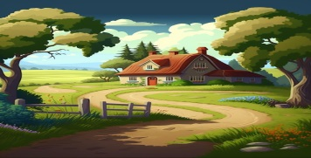**Question 1: Listen and number. There is one example. (1pt)**

**0**

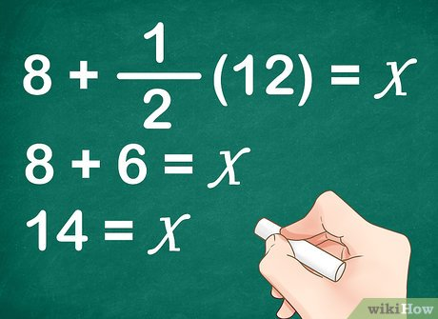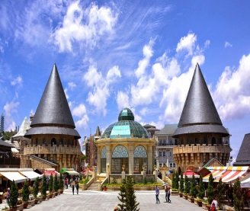

A B C D

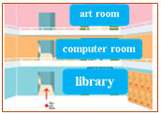**Question 2: Listen and write tick or cross There is one example. (1pt)**

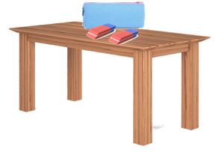

1. 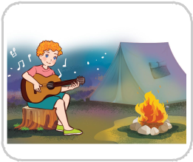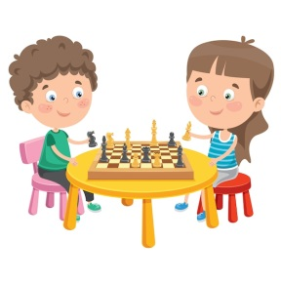 **1. T/ F 2. T/ F**

**3. T/ F 4. T/ F**

**Question 3. Listen and choose the correct answers. There is one example. (1pt)**

1. Could you tell me the way to the art room please?

______________. It's on your left.

A. Go upstairs B. Go downstairs C. Go along the corridor

1. Bill had a school trip in Yen So Park ______.

A. last Friday B. last Sunday C. last Saturday

2. What did Bill and his classmates do in the morning?

A. played the guitar B. walked around the lake C. had a party

3. Who played the guitar at the party?

A. Mr. Long B. Bill C. Bill’s class

4. What time did the school trip end?

1. at noon B. 3 p.m C. 4 p.m

**Question 4. Listen and complete. There is one example. (1pt)**

1. What did you do at Hoan Kiem lake?

We **walked around** the lake.

1. What school activity do you like, Linda?

I like **______________**projects**.**

1. Where are the crayons?

They're **_______________**the desk.

1. Whose **_______________** is it?

It's Ngoc Duc's.

1. What did you do at the campsite?

We **_______________** around the campfire.

**PART II. READING AND WRITING (20’)**

**Question 5: Look and write. There is one example. (1pt)**

**read books**

**gardener**

**libary**

**writer**

**beach**

**0. gardener**

1. ___________ 2. _____________ 3. ______________ 4._____________

**Question 6: Read and circle. There is one example. (1pt)**

1. What _______________ is she?

a. nation b. nationality c. country

1. What would you like _______________ in the future?

A. are B. be C. to be

1. Where’s the library? - It’s ______________ the second floor.

A. in B. on C. under

1. What did you do at the campsite last week? - I ______ around the campfire.

A. sing B. danced C. play

1. What school activity does he like? - He likes _________________projects.

A. playing B. reading C. doing

**Question 7 : Look, read and match. There is one example. (1pt)**

|  |  |  |
| --- | --- | --- |
| **A** | **B** | **Answer** |
| 1. Where’s the computer room? | a. I like going for a walk. | **0. d** |
| 1. What do you like doing in your free time? | b. I always play the piano. | **1. __** |
| 1. What would you like to be in the future? | c. Because it’s fun. | **2. __** |
| 1. What do you do at the weekend? | d. It’s on the third floor. | **3. __** |
| 1. Why does he like playing football? | e. I’d like to be a firefighter. | **4. __** |

**Question 8. Read the passage and answer the questions. (1pt)**

My name is Quan. My family members often play games in our free time. I really like playing chess with my father although I am not very good at it. Sometimes, my cousins come to my house to play badminton with my brother. Gardening is my mother’s hobby. My house has a small garden and she often looks after flowers or plants in her free time. Actually, our leisure activities are not always at home. At the weekend, my family goes to the supermarket to play bowling.

1. What does Quan like doing in his free time?

* **He likes playing chess with his father.**

1. What do his cousins do when they come to his house?

* ......................................................................................................................

1. What’s his mother’s hobby?

* ......................................................................................................................

1. What does his family do at the weekend?

* ......................................................................................................................

1. Is there a garden in his house?

* ......................................................................................................................

**Question 9: Reorder the words. There’s one example (1pt)**

1. did / Where / go / weekend /you /?/ last

* 🡪**Where did you go last weekend?**

1. free / do/ What / doing / in / time/ your / you / like/?/

🡪……………………………………………………………………………..

1. guitar/ She/ the/ playing/ likes/ ./

🡪…………………………………………...………………………………..

🡪…………………………………………………………………………………..

1. would/ you/ What/ like/ in/ to/ the/ future/be/?/

🡪……………………………………………………………………………..

1. danced/ We/ the/ campfire/ around/ last weekend/./

🡪…………………………………………...………………..………………..

🡪…………………………………………………………………………………..

**PART III: SPEAKING (1pt)**

|  |  |
| --- | --- |
| 1. Get to know each other (Interview) | 2. Look, point and say |
| 3. Let’s talk |  |

***-------------The End--------------***

Giáo viên coi …………..…..…… Giáo viên chấm…………………………

**ĐÁP ÁN, BIỂU ĐIỂM VÀ HƯỚNG DẪN CHẤM**

**BÀI KIỂM TRA CUỐI HỌC KÌ I – LỚP 5**

**Năm học: 2024 - 2025**

**Môn : TIẾNG ANH**

|  |  |  |  |  |  |  |
| --- | --- | --- | --- | --- | --- | --- |
| ***Question*** | *Answer* | | | | *Point* | *Total* |
| ***1*** | 1. B | 2. D | 3. A | 4. C | 0,25/each | 1pt |
| ***2*** | 1. X | 2.X | 3. V | 4. V | 0,25/each | 1pt |
| ***3*** | 1. B | 2. A | 3. B | 4. C | 0,25/each | 1pt |
| ***4*** | 1. doing | 2. under | 3. crayon | 4. danced | 0,25/each | 1pt |
| ***5*** | 1. writer | 2. library | 3. read books | 4. beach | 0,25/each | 1pt |
| ***6*** | 1. C | 2. B | 3. B | 4.C | 0,25/each | 1pt |
| ***7*** | 1. A | 2. E | 3. B | 4. C | 0,25/each | 1pt |
| ***8*** | 1. His cousins come to his house to play badminton with his brother./ They play badminton with his brother.  2. It’s gardening./ His mother’s hobby is gardening.  3. They go to the supermarket to play bowling./ They play bowling.  4. Yes, there is. | | | | 0,25/each | 1pt |
| ***9*** | 1. What do you like doing in your free time?  2. She likes playing the guitar.  3. What would you like to be in the future?  4. We danced around the campfire last weekend. | | | | 0,25/each | 1pt |

**PART III SPEAKING**

|  |  |
| --- | --- |
| 1. Get to know each other (Interview) | 2. Look, point and say |
| 3. Let’s talk |  |

**Transcripts for the test**

**Question 1. Listen and number. There is one example.**

1. **A: Can you tell me about yourself?**

**B: I live in the countryside.**

1. A:What would you like to be in the future?

B: I'd like to be a reporter.

1. A: Hi, Mai. What are you doing?

B: Hello, Ben. I'm helping my brother solve a maths problem.

He's not good at maths.

1. A: Where are the pencils?

B:They're beside the book.

4. A: Did they go to Barna Hills?

B: Yes, they did.

**Question 2.Listen and write (V) or (X). There is one example.**

1. **A: Could you tell me the way to the art room please?**

**B: Go upstairs. It's on the second floor.**

1. A: Is reading books her favorite school activity?

B: Not really. She likes playing basketball.

2. A: Where are my erasers?

B: They are in the pencil case.

3. A: What's his favorite school activity?

B: He likes playing chess.

4. A: Did you have a campfire and dance around the campfire yesterday?

B: No, I didn't. I played the guitar.

**Question 3. Listen and circle the correct answers.There is one example.**

**0. A:Could you tell me the way to the art room please?**

**B: Go upstairs. It's on your left.**

A: Hi Bill. How was your school trip to Yen so Park last Sunday?

B: It was great. We walked around the lake in the morning and watched the fish.

A: Nice. What about the afternoon?

B: Well we had a cool party. Mr. Long played the guitar and we all sang and danced happily.

A: What time did it end?

B: 4 o'clock. It was really nice.

**Question 4: Listen and complete. There is one example.**

1. A: Did you go to Hoan Kiem Lake last Sunday, Tom?

B: Yes, I did. I went there with my friends.

A: What did you do there?

B: We walked around the lake.

1. A: I like playing games.

B: What about you, Linda?

A: No, I don't like it.

B: What school activity do you like?

A: I like **doing** projects.

1. A: What are those school things?

B: They're crayons.

A: Where are they?

B: They're **under** the desk.

1. A: Excuse me.

B: Is this your school bag?

A: No, it isn't.

B: Whose **crayon** is it?

A: It's Ngoc Duc's.

1. A:Where were you yesterday, Lian?

B: I was at the campsite with my friends.

A: What did you do there?

B: We **danced** around the campfire.

**MA TRẬN ĐỀ KIỂM TRA HỌC KỲ I - LỚP 5**

**Môn: Tiếng Anh**

**Năm học: 2024 - 2025**

|  |  |  |  |  |  |
| --- | --- | --- | --- | --- | --- |
| **Skills** | **Objectives to evaluate** | **Level/ point** | | | **Total** |
| **Listening** | **Level 1** | **Level 2** | **Level 3** | 16  4.0 pts  40% |
| Listen and number | 1  0,25 | 2  0,5 | 1  0,25 |
| Listen and tick or cross | 2  0,5 | 1  0,25 | 1  0,25 |
| Listen and choose the correct answers. |  | 1  0,25 | 3  0,75 |
| Listen and complete | 3  0,75 |  | 1  0,25 |
| **Reading**  **and**  **Writing** | Look and write | 2  0,5 | 2  0,5 |  | 12  3.0 pts  30% |
| Read and circle |  | 2  0,5 | 2  0,5 |
| Look, read and match |  | 4  1 |  |
| Read and answer the questions |  | 3  0,75 | 1  0,25 | 8  2.0 pts  20% |
| Reoder the words |  | 2  0,5 | 2  0,5 |
| **Speaking** | Interview | 1  0,25 |  |  | 4  1.0 pt  10% |
| Look, point and say | 2  0,5 |  |  |
| Let’s talk |  |  | 1  0,25 |
| **Total** |  | 11  28% | 17  42% | 12  30% | 40  100% |